Test Registration, Login and Logout in Swagger
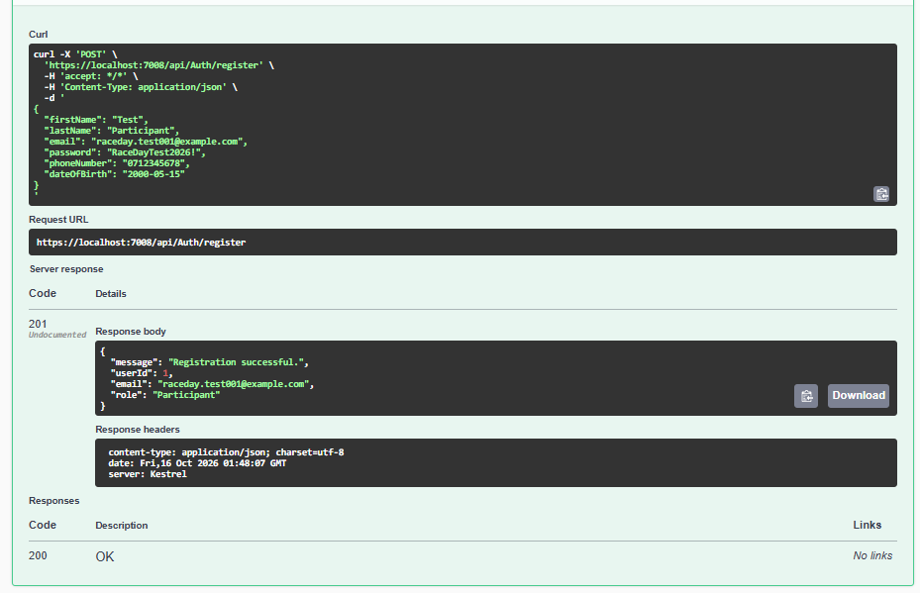
Verify the password is hashed in SQL Server
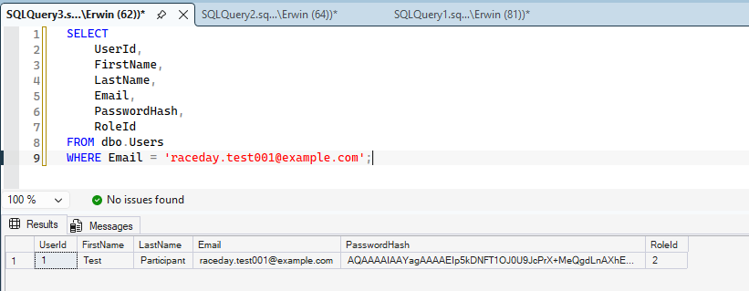

Test login successful
{
"email": "raceday.test001@example.com",
"password": "RaceDayTest2026!"
}
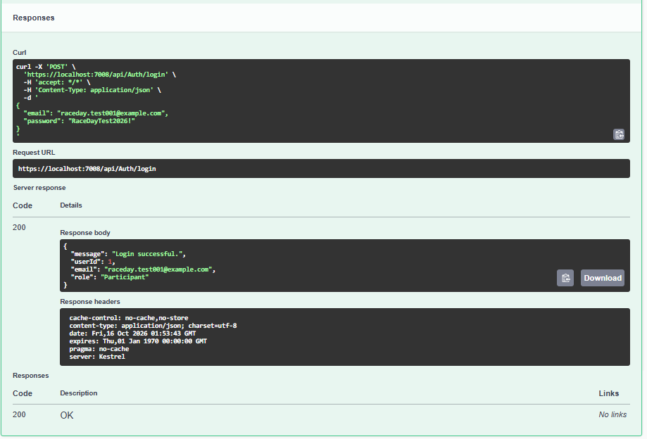
Test logout successful
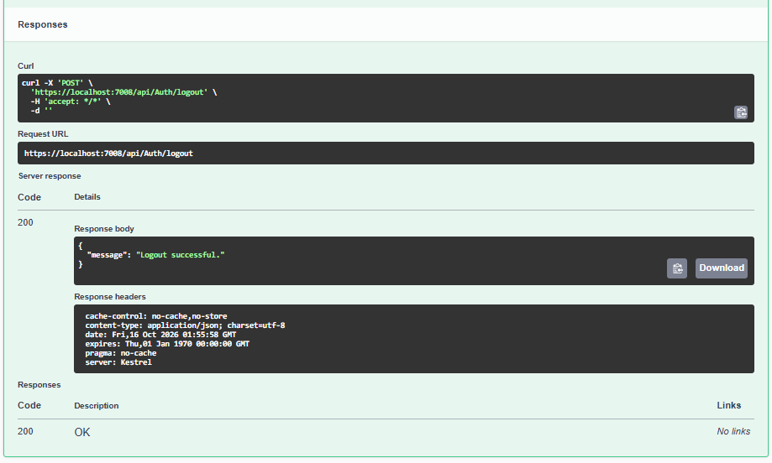

Protected Endpoints and Role-Based Access
Test anonymous access; error
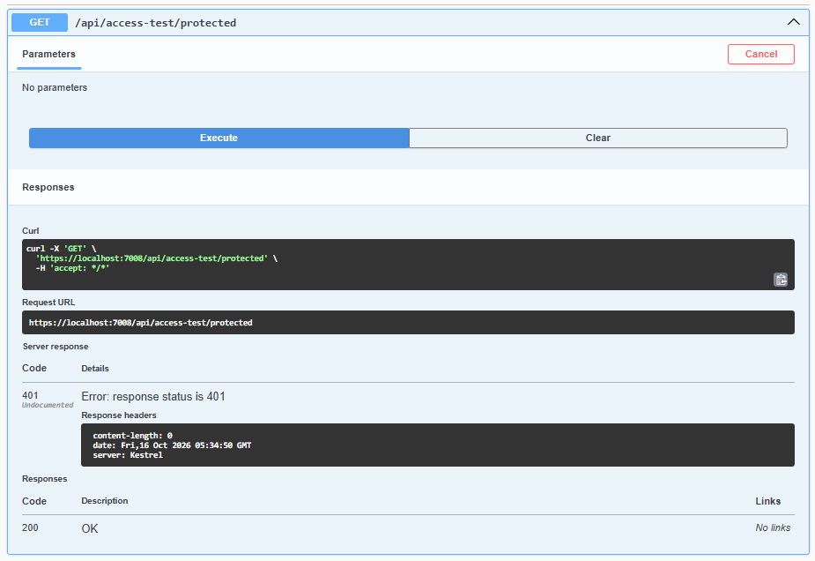
Test Participant access; 200 OK
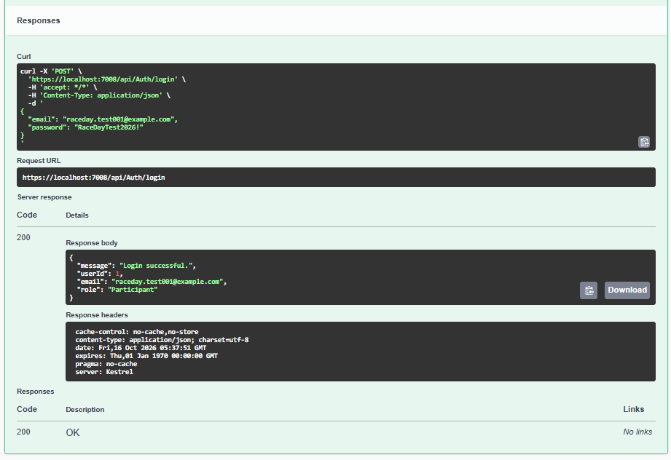
Set-Cookie
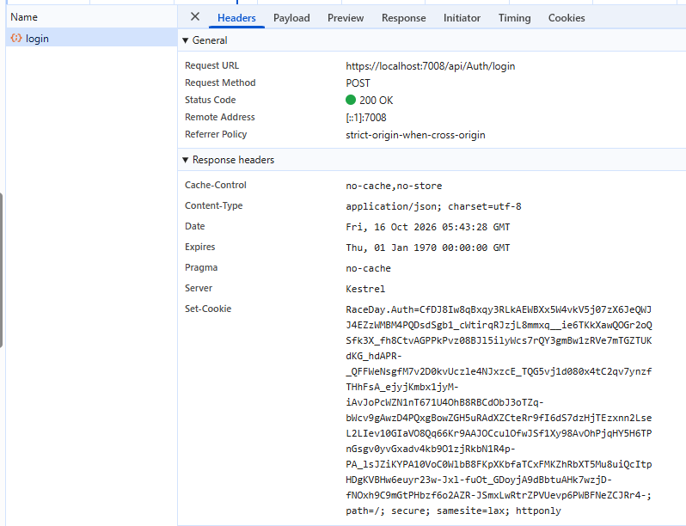
Test Organiser access rejection
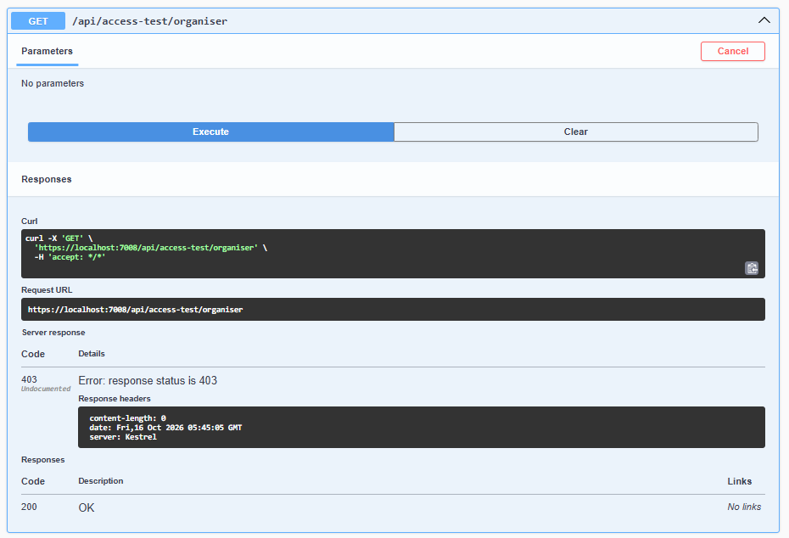
Test GET /api/profile
200 OK: The authenticated user's profile was retrieved.
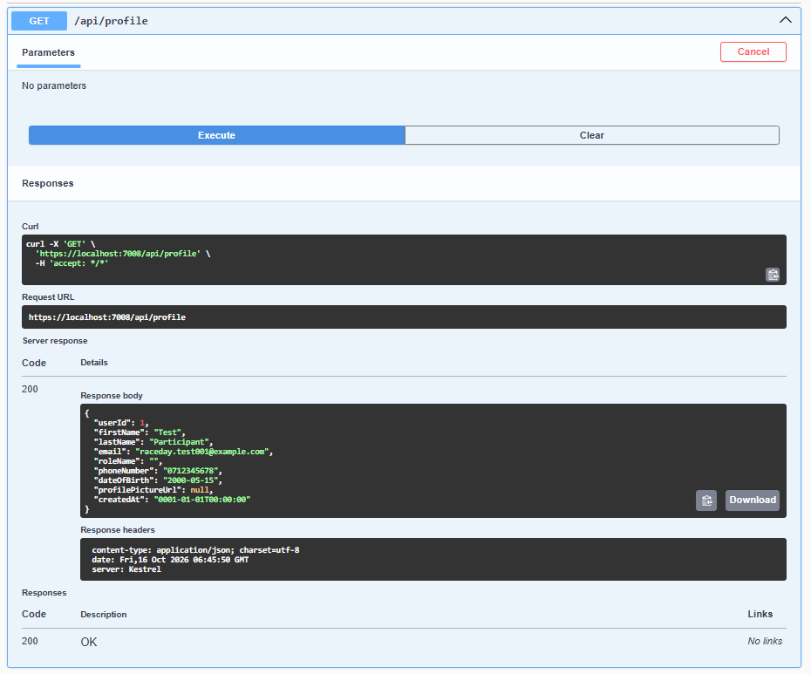

Test PUT /api/profile
Result; The update succeeded. A 204 response normally has no response body.
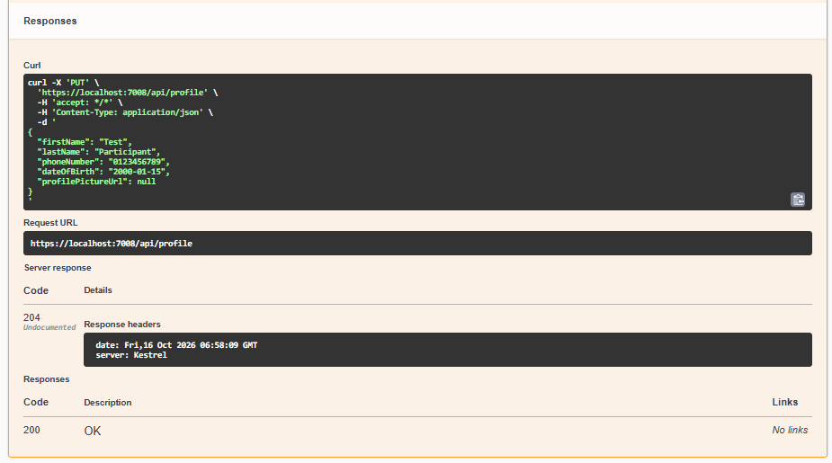
Verify the update
Run GET /api/profile
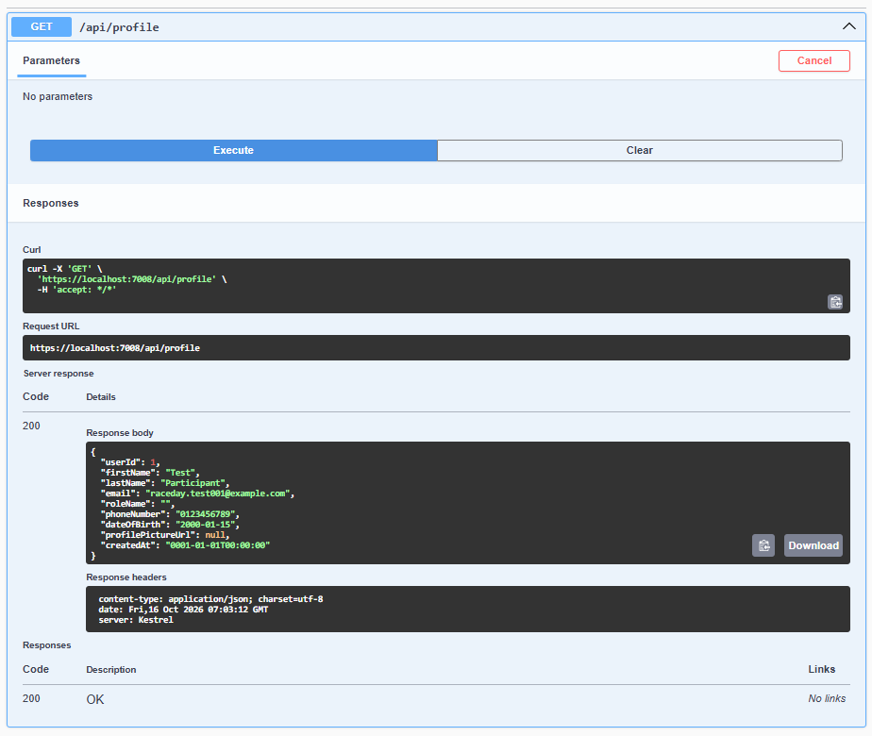

Test invalid profile data
Confirm that the API rejects a profile update when required fields are missing.
HTTP 400 Bad Request; first name and last name are required.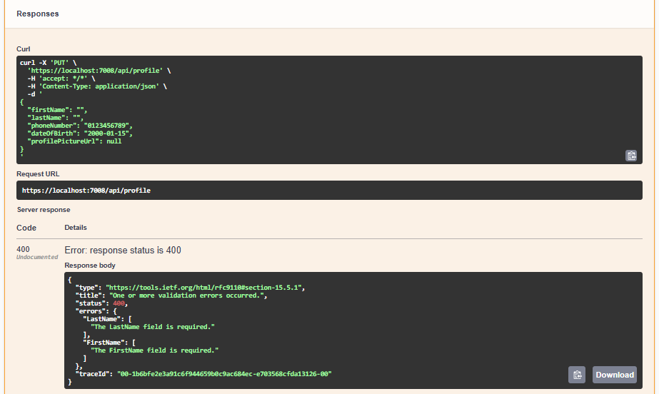
Test the authentication requirement
Verify that an unauthenticated user cannot retrieve a profile.
Result: HTTP 401 Unauthorized.
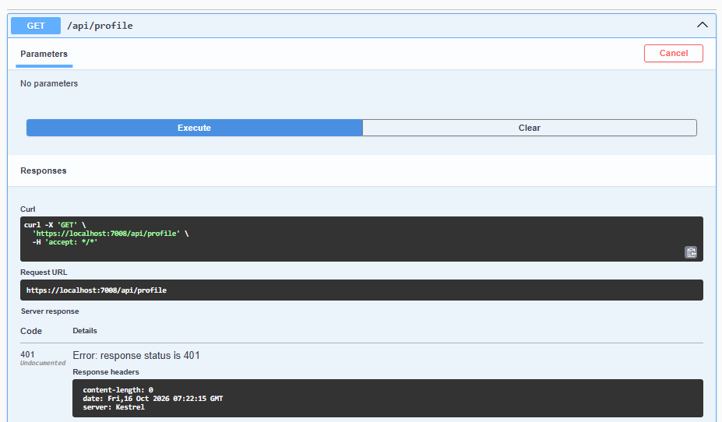

Test GET /api/events
The endpoint retrieves events from RaceDayDB_Part2.
Result; HTTP 200 OK
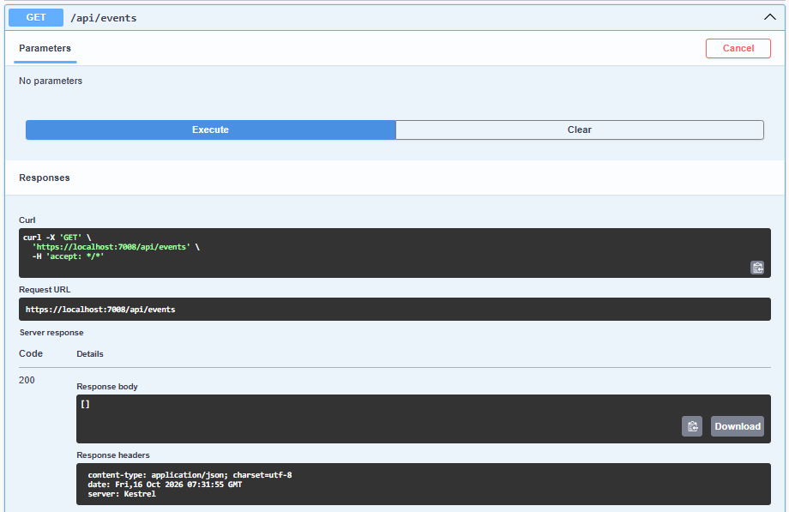

Organiser
{
"firstName": "Test",
"lastName": "Organiser",
"email": "organiser.test@raceday.local",
"password": "RaceDay_Test_2026!",
"phoneNumber": "0123456789",
"dateOfBirth": "1995-05-15"
}
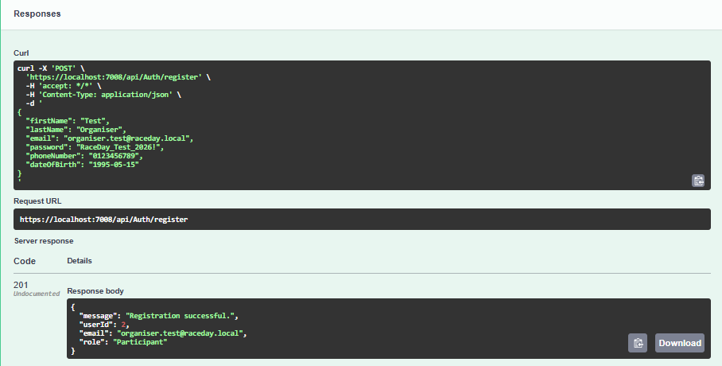
{
"email": "organiser.test@raceday.local",
"password": "RaceDay_Test_2026!"
}
Logged in as organiser
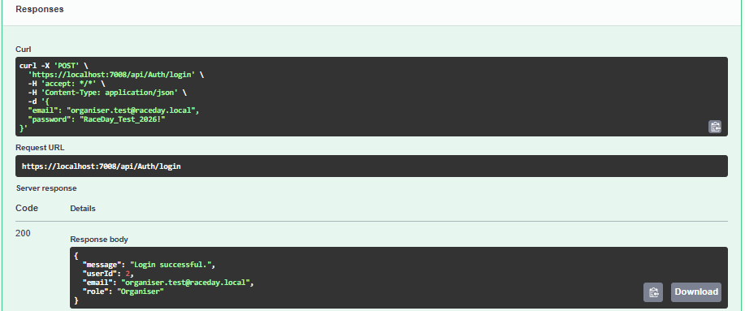
{
"eventId": 1,
"eventName": "City Fun Run",
"description": "A sample running event",
"eventDate": "2026-11-15",
"location": "Johannesburg",
"distanceKm": 5.00,
"eventType": "Run",
"bannerImageUrl": null,
"organiserId": 2
}
Event creation as Organiser has passed
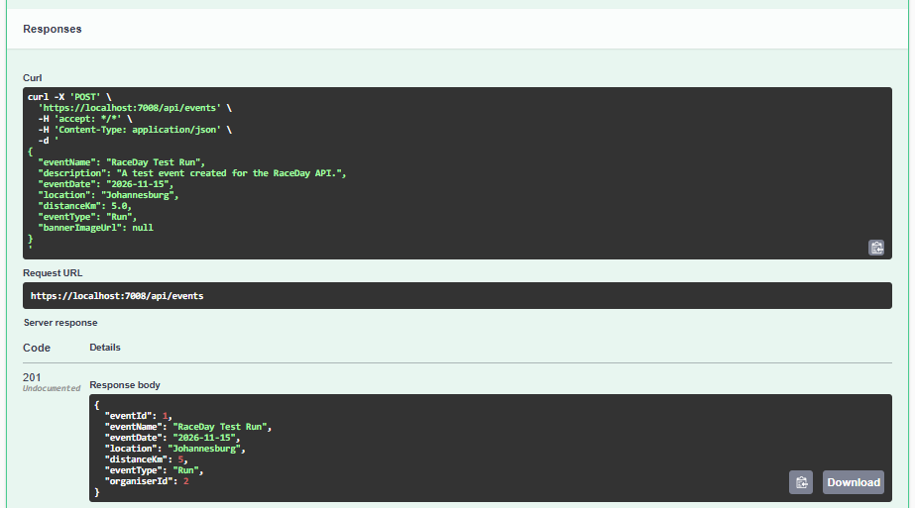

Verify the event was saved
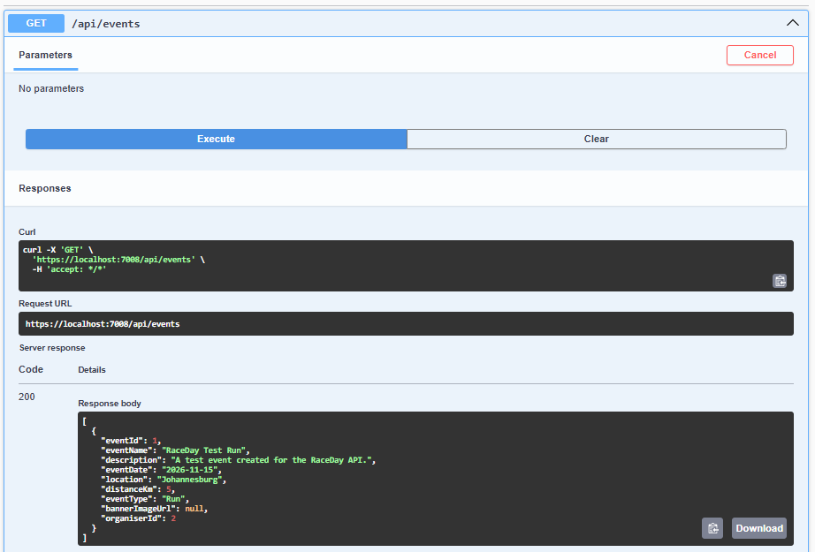

Test Participant access
Verify that a Participant cannot create events.
Result: HTTP 403 Forbidden.
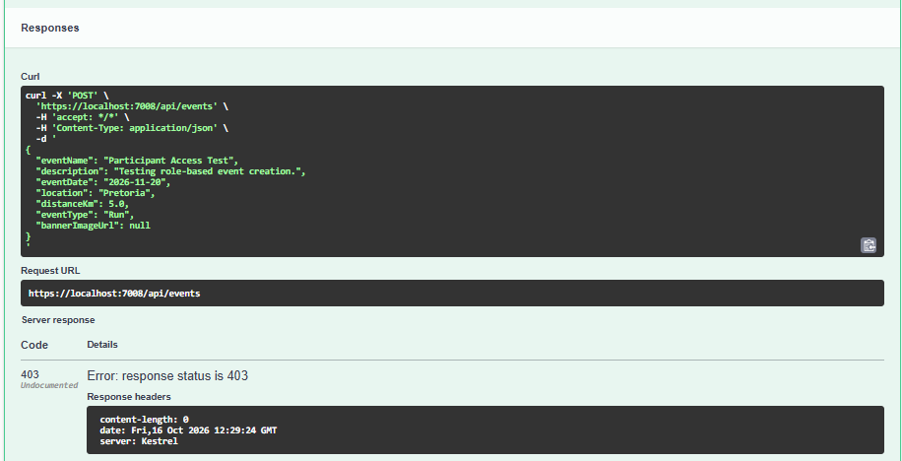
Test GET /api/events/{id}
HTTP 200 — event details returned ID 1
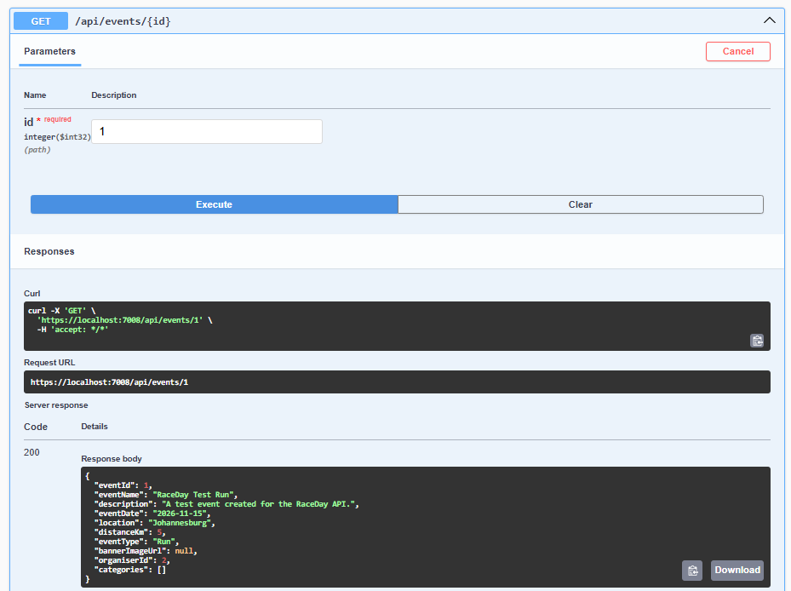
ID 2 not Found
HTTP 404 — Not Found
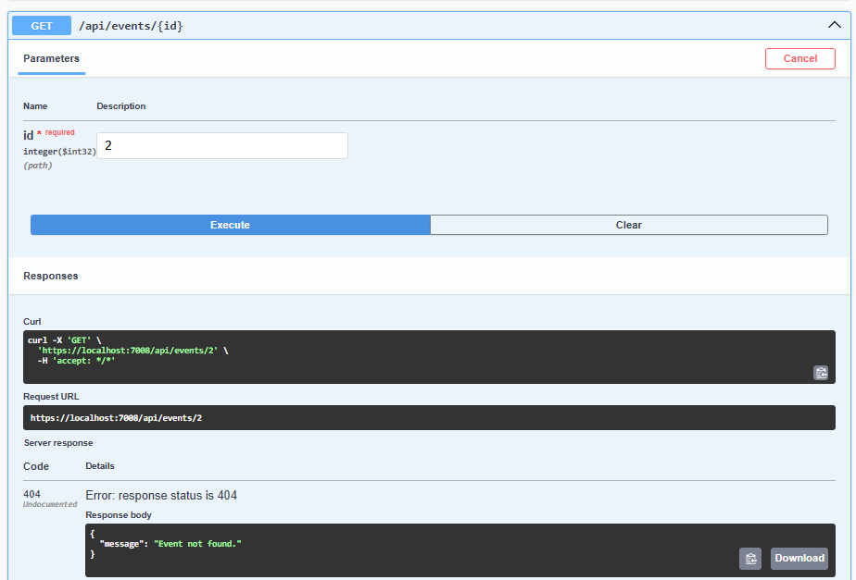
Test PUT /api/events/{id} as the event owner
HTTP 204 No Content. This means the event was updated successfully.
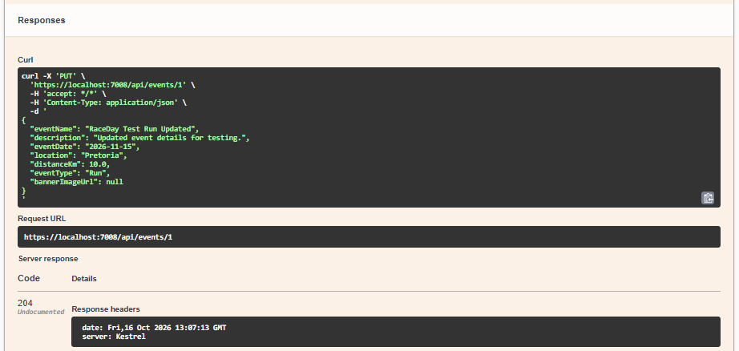

Event Updated
HTTP 204 — update succeeded
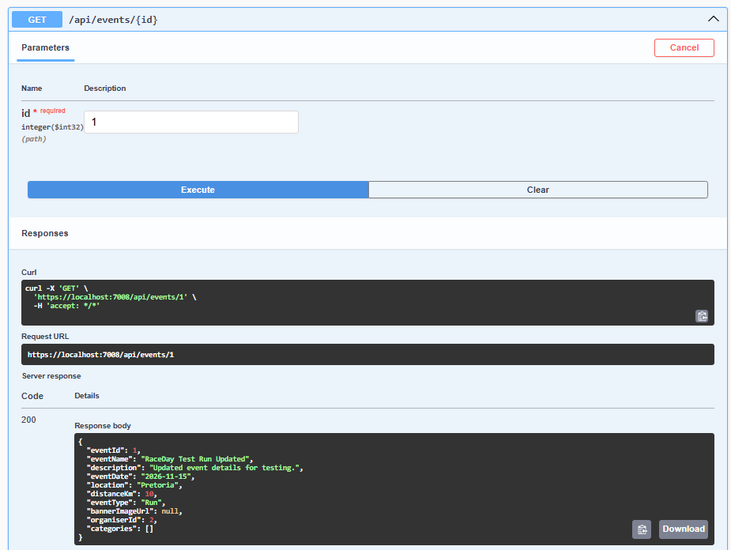

Event Update Test
Second Organiser
{
"firstName": "Second",
"lastName": "Organiser",
"email": "organiser.second@raceday.local",
"password": "Second_Test_2026!",
"phoneNumber": "0123456788",
"dateOfBirth": "1994-06-20"
}
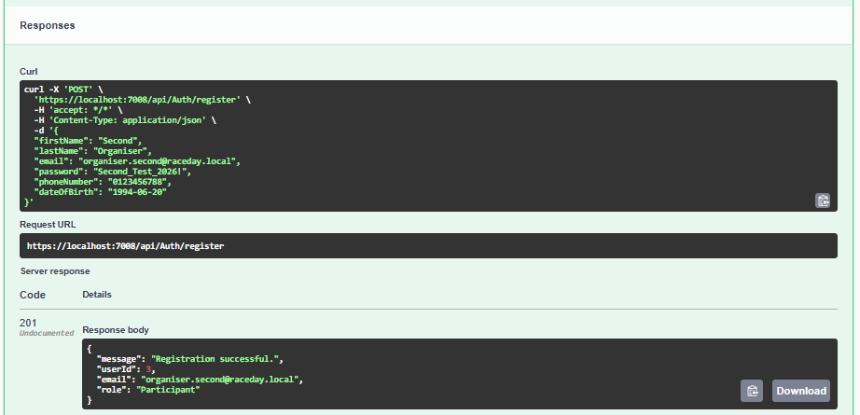
{
"email": "organiser.second@raceday.local",
"password": "Second_Test_2026!"
}
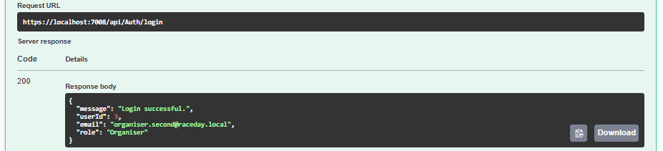
Attempt to update the first Organiser's event
HTTP 403 Forbidden.
